Requirement Analysis
Solution Requirements (Functional & Non-functional)

Date | 9 September 2026
Student Name | Burada Laxmi Sai Priyanka
Project Name | Licensed Software Installation Request Management
Maximum Marks

Functional Requirements

FR No. | Functional Requirement | Sub Requirement
FR-1 | Application Setup | Create and configure the SIRA scoped application, required tables, modules, roles, and supporting configuration.
FR-2 | Request Capture | Capture requester, software name, version, department, device, business justification, and required installation date.
FR-3 | Software Request | Provide a catalog item for licensed software installation with appropriate request information and software details.
FR-4 | Validation | Validate mandatory fields, request details, licensing information, and required attachments before the request can be submitted.
FR-5 | Approvals | Configure approval routing so software requests are reviewed before fulfillment according to organizational requirements.
FR-6 | Assignment | Automatically assign approved requests to the appropriate Software Support Team for installation and fulfillment.
FR-7 | Fulfillment | Create and track fulfillment tasks, update status/work notes, and complete the request after installation.
FR-8 | Notifications | Send notifications for request submission, approval, assignment, progress, and completion/closure.
FR-9 | Portal | Provide a user-friendly Service Portal catalog form with configured variables, UI policies, and request tracking.
FR-10 | Reporting | Support monitoring and reporting of request volume, status, approval progress, fulfillment, and completion.

Non-functional Requirements

NFR No. | Requirement | Description
NFR-1 | Usability | Provide a simple, clear, and user-friendly catalog experience for submitting software installation requests.
NFR-2 | Security | Use ServiceNow role-based access and scoped application controls to protect request and configuration data.
NFR-3 | Reliability | Ensure request submission, validation, approval, notification, and fulfillment steps operate consistently.
NFR-4 | Performance | Provide responsive catalog form behavior and timely workflow/notification processing.
NFR-5 | Availability | Ensure the application and request process are available subject to the ServiceNow platform instance.
NFR-6 | Scalability | Support additional software items, request types, approvers, and fulfillment teams as the solution grows.
NFR-7 | Maintainability | Allow administrators to update catalog variables, UI policies, approvals, flows, notifications, and rules efficiently.
NFR-8 | Data Integrity | Maintain accurate request, approval, task, status, and installation information throughout the request lifecycle.

Solution Requirements
Functional Coverage
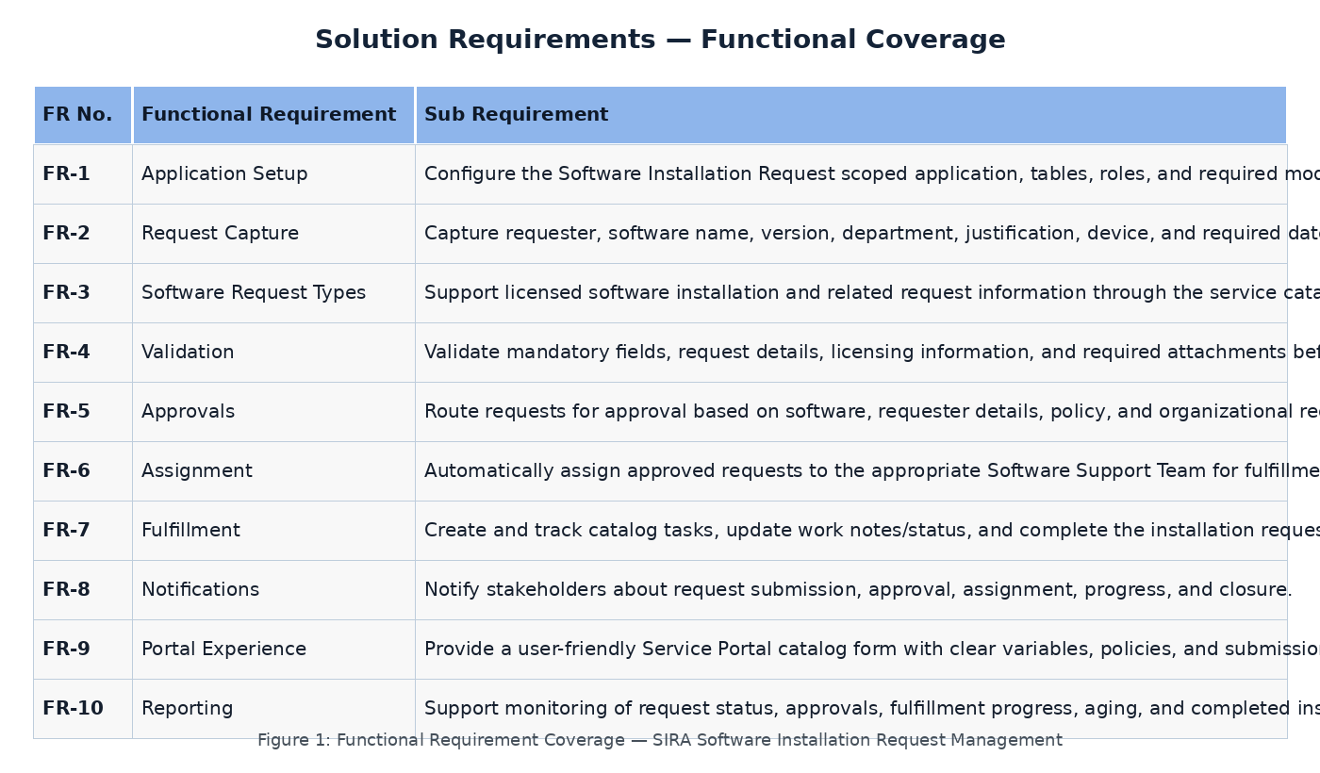

Requirement Traceability Summary

Area | Covered By | Expected Outcome
Catalog & Form | FR-2, FR-3, FR-4, FR-9 | User can select licensed software and submit complete, validated request details.
UI/UX & Policies | FR-4, FR-9 | Relevant fields and validation behavior are presented dynamically.
Workflow & Approval | FR-5, FR-6, FR-7 | Request moves through approval, assignment, fulfillment, and closure.
Notifications | FR-8 | Stakeholders receive lifecycle updates at key stages.
Security & Data | NFR-2, NFR-8 | Access is controlled and request information remains consistent.
Testing & Operations | NFR-3, NFR-4, NFR-7 | Solution can be validated, monitored, maintained, and updated.

